**BCS 4103 Advanced Database Systems**

**Group 2**

**Mastering Cooking recipe portal**

**Aggrey Kigen Bscnrb484621**

**Christine Sankei Bsclmr180119**

**Peter Maingi Bscnrb488720**

**Github blink:** https://github.com/petermaingi/bsc4107-group2/tree/master

**Mastering Cooking portal**

**Introduction**

Model a web portal where a stored procedure and triggers will display your cooking recipes under different categories.

## Database overview

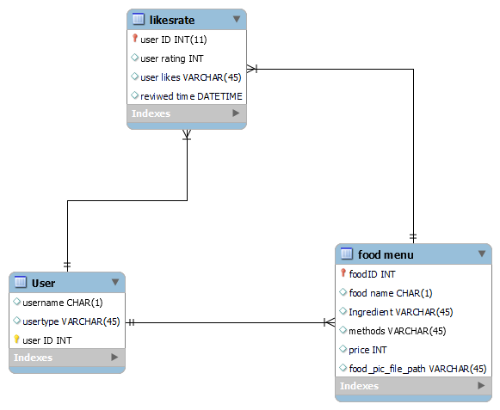

Recipe database is a resource coverage of 10 recipes, which are composed of over 20 ingredient

### **Ingredients data**

To construct the dataset, we required information of each recipe from the dataset in a structured format. The ingredients section includes information regarding the ingredients used in the recipe and their corresponding attributes

### **Cooking instructions data**

Similarly, in the instructions section, an NER model was trained to identify cooking processes, ingredients and utensils using the Stanford NER

### **Recipe of the day**

* Recipe of the Day, prominently featured on the home page, initiates the beginner user by presenting the highest ratings/likes  from database. This feature offers a peek into the Recipe database **Cooking shows in which it has been demonstrated and Recipes viewed in the last 5 Hours**, from where the user can start exploring the resource.

**Rating**

The recipe portal allows users to vote for there favorite recipe of which the vote is uniquely identified using their user id

## web interface

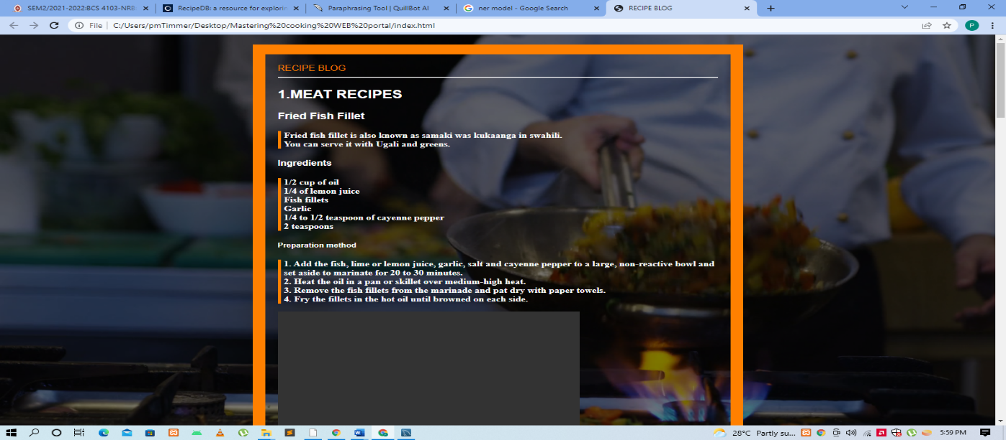

Refences

<https://www.chefspencil.com/top-20-popular-kenyan-dishes/>

[**https://www.guru99.com/er-diagram-tutorial-dbms.html**](https://www.guru99.com/er-diagram-tutorial-dbms.html)

github.com/brianc/node-postgres

https://recipes.hypotheses.org/tag/databases